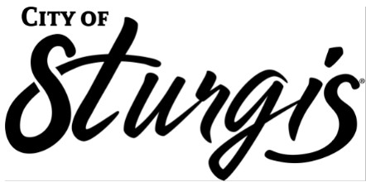

EFFECTIVE JANUARY 1, 2022, THE AGENDAS AND PACKETS ARE NOW PUBLISHED ON THE CITY’S NEW DOCUMENT MANAGEMENT PORTAL.

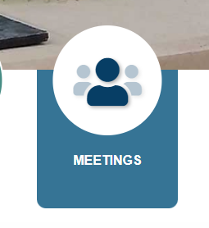
The new portal is accessed at https://sturgis-sd.civicweb.net/portal/ or simply click on the Meetings icon above the News items on the home page.

