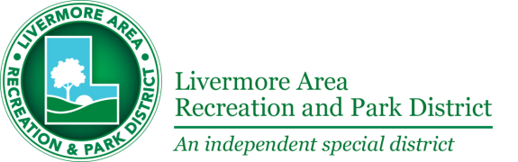

AGENDA

BOARD OF DIRECTORS
PUBLIC MEETING

WEDNESDAY, SEPTEMBER 18, 2019
6:00 P.M.

Pleasure Island Park
280 Pearl Drive, Livermore

1. Update on Current LARPD Projects

2. Comments and Suggestions Regarding Pleasure Island Park

3. Questions for Police Officer

4. Questions for Staff and Board of Directors

