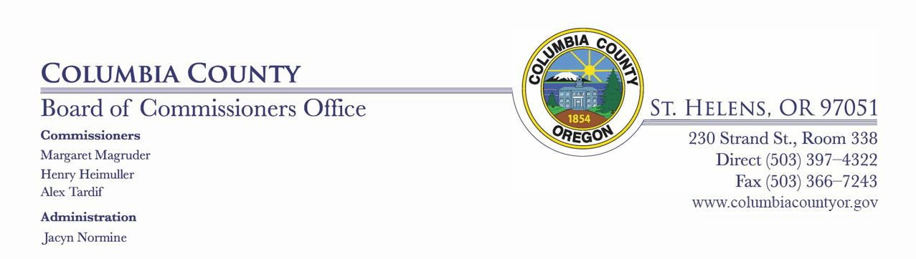

WORK SESSION

FOR COLUMBIA COUNTY, OREGON
Wednesday, April 8, 2020
1:00 PM – Board of Commissioners meeting room #338

WORK SESSION WORK SESSION AGENDA

- BOARD DISCUSSION ITEMS:

- STAFF ITEMS:

^{2:00} Clean Harbor

Amendment _1 to Agreement with Clean Harbors Environmental Services.pdf contract for Clean Harbors.pdf

BOARD COMMUNICATION April 1 2020.docx Col. Cnty Rate Increase Request 2020 (002).doc

3. EXECUTIVE SESSION:

^{2:45} 192.660 (2)(d) Jean Ripa, HR Director

^{3:15} 192.660(2)(e) Jacyn Normine, Board Office Administrator / Surplus Properties

Pursuant to ORS 192.640(1), the Board of County Commissioners reserves the right to consider and discuss, in either open session or Executive Session, additional subjects which may arise after the agenda is published.

1

