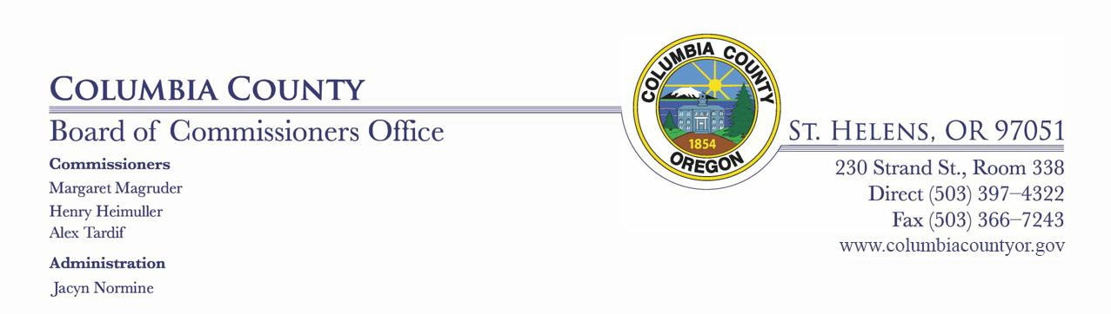

BOARD OF COUNTY COMMISSIONERS

FOR COLUMBIA COUNTY, OREGON
Wednesday, April 15, 2020 10:00 AM
Columbia County Court House via telecommunication

BOARD OF COUNTY COMMISSIONERS REGULAR AGENDA

CALL TO ORDER/FLAG SALUTE

MINUTES

April 1, 2020 Board Meeting

April 1, 2020 Work Session

April 8, 2020 Board Meeting

April 8, 2020 Work Session

VISITOR COMMENTS - 5 MINUTE LIMIT

HEARING(S)
None

CONSENT AGENDA

- Approve 2020 Liquor License On- Premises Renewal for Yankton Store and Restaurant, LLC

OLCC Yankton 291012 (1).pdf

AGREEMENTS/CONTRACTS/AMENDMENTS
None

MATTERS

//

//

DISCUSSION ITEMS

Louise Kallsttom, Finance Director - RFP recommendation and the proposal from Pauly, Rogers

Pauly Rogers Price Proposal.pdf

Pauly Rogers.pdf

2020-04-09 MEMO-AUDIT RFP RECOMMENDATION.pdf

EXECUTIVE SESSION

COMMISSIONER HEIMULLER COMMENTS

COMMISSIONER MAGRUDER COMMENTS

COMMISSIONER TARDIF COMMENTS

ADJOURNMENT

Pursuant to ORS 192.640(1), the Board of County Commissioners reserves the right to consider and discuss, in either open session or Executive Session, additional subjects which may arise after the agenda is published.
1

