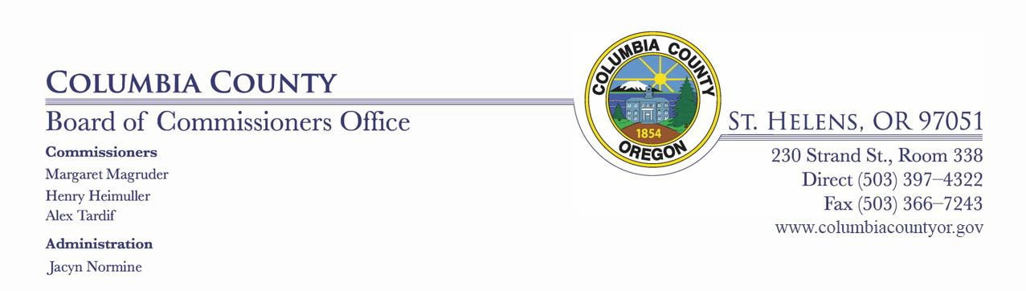

DAILY MEETING / PUBLIC HEALTH UPDATE

FOR COLUMBIA COUNTY, OREGON
April 21, 2020
9:45 AM –
via telecommunication

DAILY MEETING / PUBLIC HEALTH UPDATE DAILY AGENDA

- Public Health Update:

- Commissioners Discussion:

- Department Head & Staff Discussion Items:

- Executive Session:

1

