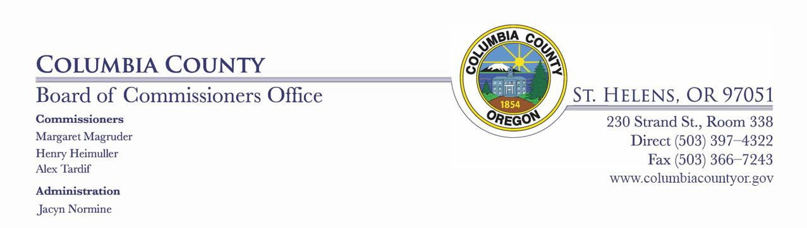

DAILY MEETING / PUBLIC HEALTH UPDATE

FOR COLUMBIA COUNTY, OREGON
Monday, April 27, 2020
9:45 AM – via telecommunication

DAILY MEETING / PUBLIC HEALTH UPDATE DAILY AGENDA

- Public Health Update:

Mike Paul, Public Health Director

- Commissioners Discussion:

- Department Head & Staff Discussion Items:

^{3.A} Clean Harbors Contract update / Kathleen Boutin- Pasterz

Contract for Clean Harbors (1).pdf

Clean Harbors 6% increase.pdf

- Executive Session:

^{4.A} 192.660(2)(d) / Jean Ripa

1

