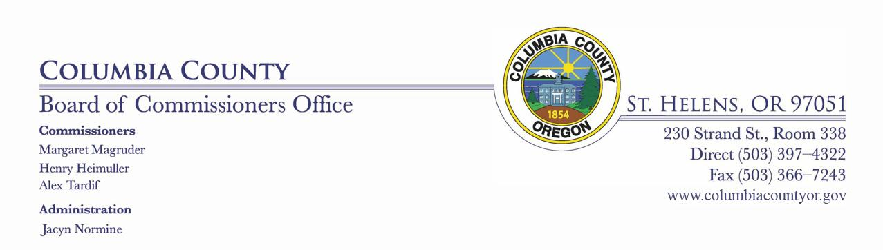

BOARD OF COUNTY COMMISSIONERS

FOR COLUMBIA COUNTY, OREGON
Wednesday, June 10, 2020
10:00 AM – Room 310 of Columbia County Court House

BOARD OF COUNTY COMMISSIONERS REGULAR AGENDA

A SUPPLEMTENTAL BUDGET WILL BE CONSIDERED DURING THIS MEETING

CALL TO ORDER/FLAG SALUTE

MINUTES

Approve the 06.03.2020 Board meeting minutes

VISITOR COMMENTS - 5 MINUTE LIMIT

PUBLIC HEALTH UPDATE

HEARING(S)

CONSENT AGENDA

- Approve Vernonia Rural Fire Protection District's Request for

Reimbursement, Certificate and Cost Bill and authorize the Chair to sign.

Vernonia Rural Fire Protection Distict 2020 reimbursement (1).pdf

- Approve Mist-Birenfeld Rural Fire Protection District's Request for
Reimbursement, Certificate and Cost Bill and authorize the Chair to sign.

Mist-Birkenfeld Fire Protection Distict 2020 reimbursement.pdf

c. Resolution No. 52-2022 In the Matter of a Supplemental Budget Reallocating Appropriations Between Budget Categories In the 2019-2020 Fiscal Year Budget.

Resolution 52-2020 with Exhibits (1).pdf

1

AGREEMENTS/CONTRACTS/AMENDMENTS

- C44-2018-1 Amendment No.1 To Intergovernmental Agreement by and between Columbia County and Oregon Health & Science University for

Health Officer.

C44-2018-1 Amendment 1 OHSU.pdf

MATTERS

DISCUSSION ITEMS

EXECUTIVE SESSION

Jean Ripa

192.660(2)(d)

COMMISSIONER HEIMULLER COMMENTS

COMMISSIONER MAGRUDER COMMENTS

COMMISSIONER TARDIF COMMENTS

Pursuant to ORS 192.640(1), the Board of County Commissioners reserves the right to consider and discuss, in either open session or Executive Session, additional subjects which may arise after the agenda is published.

2

