TO: Columbia County Solid Waste Advisory Committee (SWAC) members, Alternates, Staff and City Ex-Officio Representatives
From: Jake Anderson, Solid Waste Program Coordinator
RE: Columbia County Solid Waste Advisory Committee Meeting
Thursday February 6, 2025, virtual and in person at Healy Hall Public Works Department 1054 Oregon St, St Helens starting at 10:00am

Please join the meeting from your computer, tablet, or smartphone.
Microsoft Teams Meeting
Meeting ID: 274 497 769 014
Passcode: LasFW2

Agenda

Welcome

Approve November Minutes
Update on Solid Waste Department

- Board Members
  - One position open for At-Large member.
    - Welcome Austin Carter Nadeau
    - Nick, Joshua, and Austin’s have been reappointed
- Sharps container exchange program started Oct 2016 and expanded to five Fire Districts in April 2021. We collect registrant sheets at the transfer station and remote fire stations as well as full sharps containers.
  - Registrant Data – Total Registrants: 1,180 as of February 4th, 2025
    - Transfer Station: 1032
    - Scappoose CRFPD: 70
    - Vernonia CRFPD: 21
    - Clatskanie CRFPD: 56
    - Rainier CRFPD: 1
  - Sharps Purchased
    - 7254 total containers as of February 4, 2025
      - 6414 purchased by solid waste = $25,956.92
  - Advertising sharps program
    - Still in planning phase, working with David Brooke on DS ad
    - Looking to promote through social media, billboard, newspaper, and other methods
    - Combine with Dumpstoppers Program advertisement
    - Spotlight article summarizing the program and its success
- Dumpstoppers – in 2024, we had 74 Dumpstopper cases. The program is a collaborative effort involving Land Development Services, Solid Waste, and Community Justice work crew to clean up dumpsites (~$1,000/month). The tipping fees last two years are ~ $2,000/year. Dave Carlberg records the cases and investigates dumpsites as the Columbia County Code Compliance Specialist.
  - Advertising the success of this program
    - Billboard, social media, newspaper article, and other outlets to show the success of the program
    - Overall, there has been much less illegal dumping this year, further showing the success of the program.
      - Past Years from Dave Carlberg:
      - 2023 – 83 cases
      - 2022 – 81 cases
      - 2021 – 92 cases
      - 2020 – 76 cases

      - The most complaints came in on:

      - 2024 – Scappoose Vernonia Highway, Scappoose (12 complaints)
      - 2023 – Smith Road, Columbia City (16 complaints)
      - 2022 – Smith Road, Columbia City (19 complaints)
      - 2021 – Smith Road, Columbia City (15 complaints)
      - 2020 – Smith Road, Columbia City (14 complaints)

      - Smith Road has finally been unseated as the top complaint getter. Just and FYI, Smith Road had 9 complaints and Cater Road came in at 7!

- Private Property Cleanups
  - 26623 Cannon Road
    - Final Data Summary and Total Cost
      - 28 days - community justice work crew = $10,500
      - 56.54 tons of garbage + 1460 tires collected = $18,770.12
      - Vehicle Cleanup Cost (23 total): $24,950.00
      - Asbestos Testing and Abatement (10 RVs/Trailers): $5,308.50
      - Admin Cost: $7,456.59
      - Total Cost: $66,985.21
- Transfer Station
  - Transfer station repairs and upgrades
    - All pumps are currently working; however, need to add timer to aerator pump in vault
    - Looking at solutions for using 2 outflows, one to tipping floor, one directly to the vault
      - Going to reach out to Gordon’s Family plumbing
    - Fence repair has been completed
    - Gutter repair has been completed
    - Tree trimming and removal completed
  - Upcoming repairs and maintenance
    - In progress: facilities working on purchasing materials to add tread to stairs
- Columbia County’s Pilot ReUse Program
  - Shipping containers and New Employee
    - 3 20ft containers with 6 7-ft roll-up doors. Cost ~ $33k
      - Cost includes lighting, curb ramps, and shipping/placement.
    - TS Operations contract (expires March 2025) has been amended to include pilot program
  - Focus: Fast Moving Items
    - Hudson staff i.e., New Position are solid waste professionals and can identify reusable items to divert them from the landfill.
  - Hudson ReUse position (Resource Specialist/Diversion Specialist) job responsibilities have been reviewed and finalized
  - Program Hours and Policies
    - Nonprofit Hours: Non-profit availability will determine hours of program
      - Top Notch hours: 10am-5pm M-Sat.; Habitat hours: 9am-5pm T-Sat.
    - New Employee hours: Tuesday through Saturday, 5 8-hour shifts
      - Predicting 9am – 4pm schedule
    - Large sign with rules, policies, and procedures
    - Sign with information: “About the Program”
  - Next Steps
    - Working on Building Permit; Land Use Permit has been completed
      - 12 Shrubs have been removed
      - Gathered 4 estimates for gravel pad and container footings
      - Once PO is created, TFT will begin sketching drawings for footings to be included with Building Permit application to City
- Columbia County Transfer Station tonnage since 2016 – present
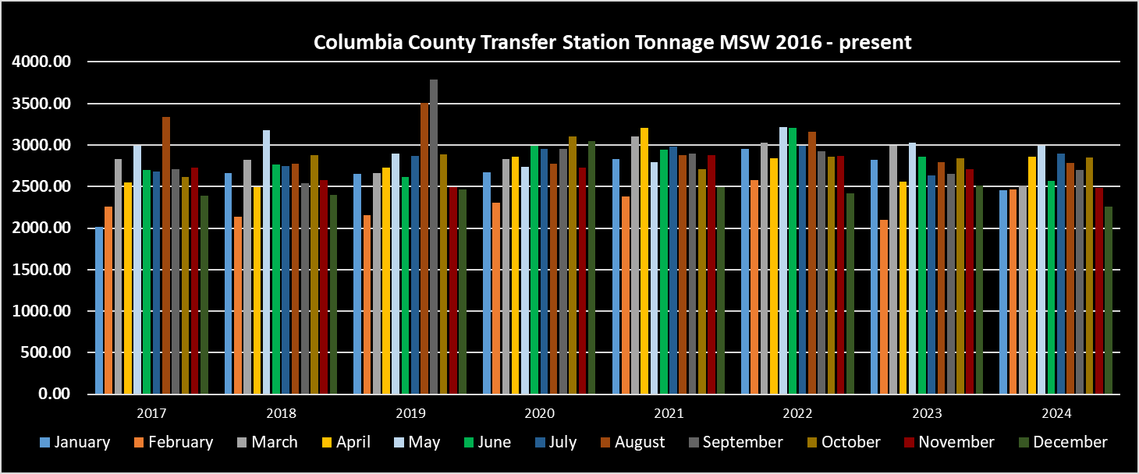
- Update on HHW collection program
  - 2025 HHW Schedule
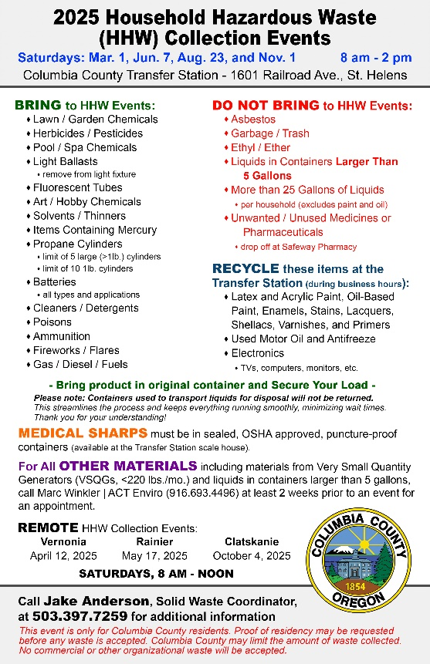
  - HHW Changes and Updates
    - Clatskanie paved parking lot site closer to the city pool/skatepark worked so much better.
    - Will advertise again for the remote events, St Helens events don’t need advertising in my opinion.
  - Modified survey/data process
    - Digital Survey: Laminated QR code that residents have the option to scan and complete the survey at the event.
    - I want to find an alternative to fill out the survey for residents, then Dave and I can both fill out the surveys for each vehicle, and it’s all digital right away. Residents prefer paper form.
  - 2024 HHW Costs & Participation
Columbia County HHW 2024 | Vehicles | Costs
March St Helens | 203 | $15,770.26
April Vernonia | 58 | $4,940.81
May Rainier | 43 | $10,201.39
June St Helens | 240 | $27,939.61
August St Helens | 248 | $26,132.36
October Clatskanie | 48 | $6,345.17
November St Helens | 178
Total | 1018 | $ 91,329.60

- Recycling/Waste Reduction Education & OTR Reports
  - OTR Reports
    - Looking to create IGA with Scappoose/St Helens so that both cities have a local outreach and education team for recycling/composting.
    - OTR requirements:
      - Postcard/Mailer sent to all existing customers
      - 4 social media posts
        - Why recycling/composting is important
        - Materials collected
        - Materials preparations instructions
        - 2024 HHW schedule and Hudson/WM collection schedules
    - Confirmed with DEQ that handing out information at the Transfer Station counts as in-person event requirement. For Scappoose, would need to table there at the farmer’s market.
- RMA/EPR Updates
  - Funding Agreement Due March 31st
    - Q: ...[B]y selecting full authorization, the county doesn't receive any funding from the PRO and all of it goes directly to the haulers?
    - A: Full authorization means that you are authorizing your selected service provider or other entity to receive all eligible funding from that funding category (1 of 5). By selecting partial authorization, there would then be some arrangement made between all the stakeholders (i.e. your jurisdiction, the service provider/other entity, and the PRO). It would be during this contracting phase that specific funding distributions would be made. DEQ would not oversee those arrangements.
    - Q: ...[I]f we selected partial, we would receive funding, but would also be responsible for distributing it to our service providers?
    - A: By selecting partial authorization, you are indicating to the PRO - in this case Circular Action Alliance (CAA) - that you are wanting to arrange a contract where your local government would receive part of the funding and some funding would be allocated to your selected service providers or other entities. Ideally, you would not be distributing funds that are authorized for a selected service provider/other entity, they would receive funding directly from the PRO for eligible expenses, and your local government would be notified when payments on your behalf are made.
    - Q: Could this funding be used for things other than programming like an outreach and education position for the county?
    - A: DEQ is working on formulating a list of approved, industry best-practice, contamination reduction programming elements per ORS 459A.929. That being said, local governments would not necessarily need to select from the approved list. All eligible expenses could be fundable by the PRO. Ultimately, you would work with the PRO to determine if the projects mentioned here would qualify for funding. I've also copied Gretchen Sandau, the NWR Regional Specialist, who may also be able to weigh in on issues pertaining to Opportunity to Recycle (OTR) compliance. Additional information regarding contamination reduction programming can be found in ORS 459A.929.
- Updated DCR
  - New report with 2023 data due March 3rd; New report with 2024 data due April 14th
    - March 3rd due date is to help finalize and identify any changes or adjustments needed to have the report ready for this years rate review.

Next SWAC meeting is the Rate Review. The public meeting will be Thursday May 1, 2025, from 10:00 AM – 10:30 AM virtually and at Healy Hall, Public Works Department 1054 Oregon St, St Helens, OR

