**TO: Columbia County Solid Waste Advisory Committee (SWAC) members, Alternates, Staff and City Ex-Officio Representatives**

**From: Jake Anderson, Solid Waste Program Coordinator**

**RE: Columbia County Solid Waste Advisory Committee Meeting**

**Tuesday August 5, 2025, virtual and in person** **at Healy Hall Public Works Department 1054 Oregon St, St Helens from 10:00am to 11:30am**

**Please join the meeting from your computer, tablet, or smartphone.**

**Microsoft Teams Meeting**

Meeting ID: 274 497 769 014

Passcode: LasFW2

**Agenda**

**Approve May Minutes**

**Update on Solid Waste Department**

**Regular Agenda 10:00am – 11:30am**

1. **Board Members**
   1. **At-Large Members**
      * Introduce Samantha Hawkins from St Helens
   2. **Industrial Representatives**
      * **Welcome Derek Ranta and Greg Rouse as new Industrial Representative Alternates for Waste Connections and WM**
        + If you still need to fill out an application, please let me know so we can make your position on the roster official
2. **Sharps Container Exchange Program -** started Oct 2016 and expanded to five Fire Districts in April 2021. We collect registrant sheets at the transfer station and remote fire stations as well as full sharps containers.
   1. **Registrant Data – Total Registrants: 1,233 as of May 7**
      * Transfer Station: **1061**
      * Scappoose CRFPD: **74**
      * Vernonia CRFPD: 21
      * Clatskanie CRFPD: **76**
      * Rainier CRFPD: 1
   2. **Sharps Purchased**
      * 7974 total containers as of August 4, 2025
        + 7134 purchased by solid waste = **$33,755.00**
   3. **Advertising sharps program**
      * Mark Pacheco sent ideas for Sharps and Dumpstoppers program advertisement, working on final decision for which methods to go with
      * Looking to promote through social media, billboard, newspaper, and other methods
      * Spotlight article summarizing the success of the programs
3. **Dumpstoppers - in 2024, we had 74 cases.** So far this year, we’ve had **57** cases.The program is a collaborative effort involving Land Development Services, Solid Waste, and Community Justice work crew to clean up dumpsites (~$1,000/month). The tipping fees last two years are ~ $2,000/year. Dave Carlberg records the cases and investigates dumpsites as the Columbia County Code Compliance Specialist.
   1. Advertising the success of this program
      * Billboard, social media, newspaper article, and other outlets to show the success of the program
        + Still seeing small dumpsites here and there
        + Haven’t needed the work crew as much this year
          1. Truck keys have been misplaced by Community Justice Department..
        + Dave Carlberg and I delivered the new DS pickup truck to have lift gate installed
4. **Transfer Station**
   1. **Transfer Station repairs and upgrades**
      * Main pumps in the vault are currently working
      * Grinder pump in the tunnel is out, working with Hillsboro pump on solution and will see if manufacturer can send replacement
      * Looking at solutions for using 2 outflows, one to tipping floor, one directly to the vault
        + Hillsboro pump can assist with this.
      * Having issues with people leaving all types of oil on the cart, when we only accept motor oil and antifreeze
        + Could reach out to other vendors who accept all oils together

1. **Columbia County’s Pilot ReUse Center Program**
   1. **Shipping containers and New Employee**
      * 3 20ft containers with 2, 7-ft roll-up doors each, and curb ramps.
      * TS Operations contract (expires March 2025) has been amended to include pilot program
   2. **Focus: Fast Moving Items** 
      * Hudson staff i.e., New Position are solid waste professionals and can identify reusable items to divert them from the landfill.
      * Habitat will be a great resource for learning what items are usually safe to reuse and are sold often, durable and useful.
   3. **Hudson ReUse position posted, few applicants thus far**
      * Kan and Josh interview 2 prospects, one seemed like a good fit
   4. **Program Hours and Policies** 
      * Nonprofit Hours: Non-profit availability will determine hours of program
        + Top Notch hours: 10am-5pm M-Sat.; Habitat hours: 9am-5pm T-Sat.
      * Priority given to not-for-profit orgs: AMANI Center, Community Action Team, DHS, CCMH
      * I or ReUse employee will communicate with orgs via private email or facebook group
      * New Employee hours: Tuesday through Saturday, 8-hour shifts
        + Predicting 8am – 4pm schedule
      * Large sign with rules, policies, and procedures
      * Sign with information: “About the Program”
   5. **Next Steps**
      * Meet with nonprofits to discuss what items they sell/need the most, and to discuss how program will work, and which orgs will be given priority
2. **Columbia County Transfer Station Tonnage Report – 2017 – present**



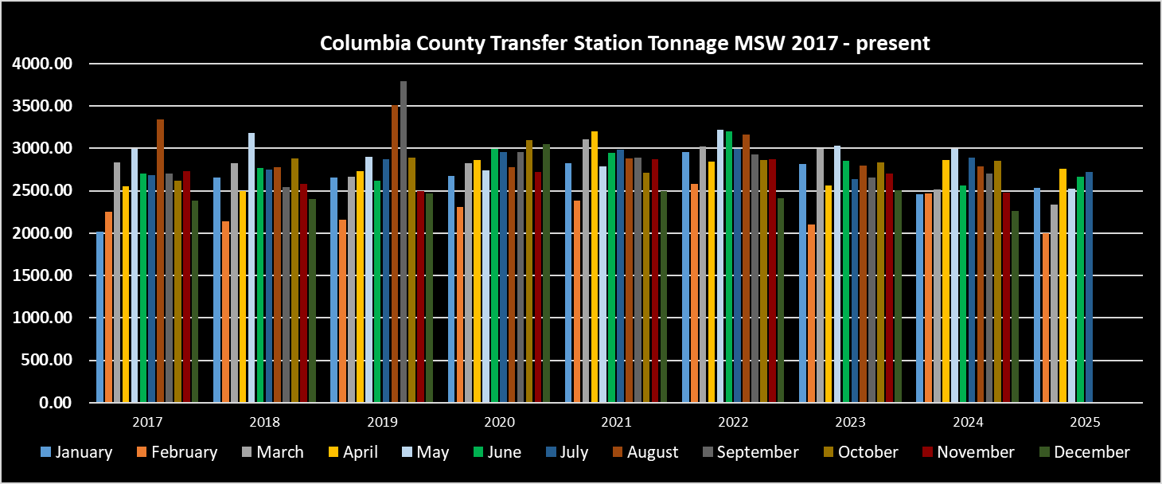

1. **Update on HHW Collection Program**
   1. **2025 HHW Schedule:**
      * Transfer Station: March 2, June 8, ***August 24***, **November 2**
      * Remote: Vernonia: April 13, Rainier: May 18, **Clatskanie: October 5**
   2. **HHW Changes and Updates**
      * Still advertising HHW flyer for remote events
   3. **Modifying survey/data processes for next year**
      * Created digital form for surveys, to ease the process of recording data. There will be a laminated QR code that residents will have the option to scan and complete the survey at the event. Then the data is stored in Microsoft forms until all surveys have been recorded, then I transfer to excel spreadsheet.
   4. **2025 HHW Costs & Participation**

|  |  |  |
| --- | --- | --- |
| **Columbia County HHW 2025** | **Vehicles** | **Costs** |
| **March St Helens** | **214** | **$20,740.66** |
| **April Vernonia** | **56** | **$7,923.62** |
| **May Rainier** | **39** | **$4,453.45** |
| **June St Helens** | **235** | **$28,721.43** |
| **August St Helens** |  |  |
| **October Clatskanie** |  |  |
| **November St Helens** |  |  |
| **Total** | **544** | **$61,839.16** |

1. **Recycling/Waste Reduction Education & OTR Reports**
   1. **OTR Reports**
      * Scappoose and St Helens 2024 reports were both approved
      * Gretchen released updates on OTR report requirements
      * Last year’s requirements:
        + Postcard/Mailer sent to all existing customers
        + 4 social media posts
          1. **Why recycling is important**
          2. **Materials collected**
          3. **Materials preparations instructions**
          4. **2025 HHW schedule and Hudson/WM collection schedules**
      * This Fall I will be working on setting up IGA’s with St Helens and Scappoose for county to complete OTR reports on behalf of the cities
        + Gretchen has sent over example IGA’s from Washington County and Clackamas County that we can use for reference
   2. Need to attend in-person event in Scappoose, likely will work the Scappoose Farmers Market
      * WM’s new intern Priscilla is planning on visiting this September
        + She can provide WM materials, a game for kids, and I can bring county’s tent/tables/chairs and our flyers
2. **RMA/EPR Updates**
   1. **I completed my estimation project of Columbia County’s population served and sent to CAA**
   2. **We completed and signed the PFA on time and are now working on the Contamination Reduction Addenda**
      * CAA just sent back a countersigned PFA, meaning we are good to submit the contamination reduction addenda and be finished with this process

**Next SWAC meeting is on Thursday November 6, 2025, from 10:00am – 11:30pm virtual or at Healy Hall, Public Works Department 1054 Oregon St, St Helens, OR.**