Columbia County Sheriff’s Office Hiring Event
July 23rd 7AM to 10 AM
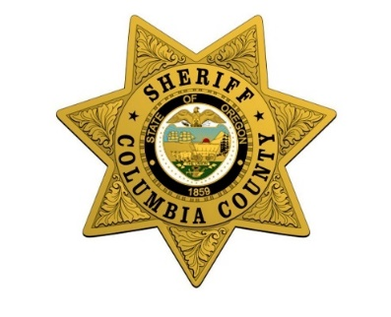

On July 23rd from 7 AM to 10 AM, CCSO will be hosting a hiring event for the following positions:
Entry Level Corrections Deputy
Lateral Corrections Deputy
Entry Level Enforcement Deputy
Lateral Enforcement Deputy

Take advantage of this opportunity to complete several phases of the hiring process within one day.
At the event you will have the opportunity to participate in the following activities;
-FREE Written Testing for Corrections Deputy Positions ($40 Value)
-FREE Physical Fitness Testing ($90 Value)
-Submit Job Application
- Connect with CCSO Recruiters
What to Bring/Wear:
- Driver’s license
-Athletic apparel (For the fitness testing)

.
Location Details:
Warren Community Fellowship
56523 Columbia River Hwy,
Warren, OR 97053

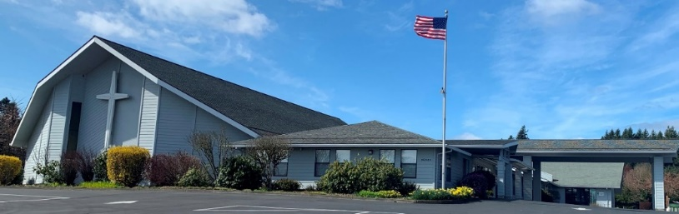

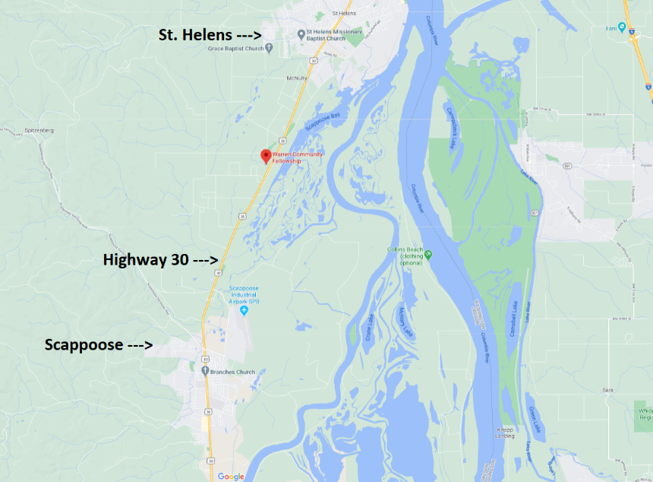

*For further inquiries, please contact Sergeant Chris Neifert*
Chris.Neifert@Columbiacountyor.gov

