
PLACERVILLE PLANNING COMMISSION
Special Meeting Monday, June 8, 2026
5:00 PM
Town Hall
549 Main Street, Placerville, CA 95667

Planning Commission Members
Kris Kiehne, Chair Amy Lepper, Vice Chair
Alyssa Stratton Catherine Silvester Kirk Smith

AGENDA

- CALL TO ORDER AND PLEDGE OF ALLEGIANCE TO THE FLAG
- ROLL CALL: Chair Kiehne, Vice Chair Lepper, Commissioner Silvester, Commissioner Smith, and Commissioner Stratton

ITEMS OF INTEREST TO THE PUBLIC/PUBLIC COMMENT– NON-AGENDA ITEMS
This portion of the meeting is reserved for people wishing to address the Commission on any matter not on the agenda and the subject matter is within the jurisdiction of the Planning Commission. State law prohibits the Commission from acting on items not listed on the agenda except by special action of the Planning Commission under specified circumstances.

WRITTEN COMMUNICATIONS – NON-AGENDA ITEMS
Written comments received on non-agenda items pertaining to business within the jurisdiction of the Planning Commission. These are not items for discussion but can be referred to by staff for consideration.

MATTERS FROM COMMISSIONERS
  - Historic Design Review discussion on updates to the City Council.

ADJOURNMENT
The Planning Commission normally ends its meetings by 10:00 pm. Items remaining on the agenda after 10:00 PM will be continued until the next Planning Commission Meeting. The Commission meets regularly on the first and third Tuesday of each month at Town Hall in the City Council Chambers; additional meetings may be scheduled as needed.

GOVERNING REGULATIONS AND RULES: The Commission conducts all meetings in accordance with the "Ralph
M. Brown Act" (California Government Code Sections 54950, et seq.), per the City's Committee, Commissions & Board Policy Manual (City Council Resolution No. 7578), and the Planning Commission Bylaws.
MEETING ACCESS: The City of Placerville wishes to make all its public meetings accessible to the public. Upon request, this agenda will be made available in appropriate alternative formats to people with disabilities, as required by 42
U.S.C. §12132 of the Americans with Disabilities Act of 1990. Any person with a disability who requires modification or accommodation in order to participate in a meeting should direct such request to the City Clerk (530) 642-5531 at least 72 hours before the meeting, if possible.
CELL PHONES: The Planning Commission appreciates your cooperation in turning off all cell phones.
AVAILABLE INFORMATION: Materials related to items on this Agenda are available for public review in the Develop- ment Services Department at City Hall, 3101 Center Street, 2nd floor, during normal business hours. Agendas and Staff Reports are also made available online at the Planning Commission Agenda webpage.
OPPORTUNITY TO APPEAL: Any aggrieved person or persons dissatisfied with a Planning Commission decision may appeal that decision to the City Council within 10 calendar days per Government Code Section 65009. Appeals can be made by any interested party by submitting a written appeal request and appeal fee to the Placerville City Clerk, 3101 Center Street, Placerville, California, 95667.
PUBLIC COMMENT: Speakers shall step up to the podium microphone to address the Commission and are limited to a presentation of three (3) minutes, unless otherwise determined by the Chair. Groups or organizations are encouraged to select a spokesperson to speak on their behalf.
WRITTEN COMMENT: You may submit your comments by e-mail to pv.planning@gmail.com, or in-person at the Development Services Department, City Hall – 2nd Floor, 3101 Center Street, Placerville, CA 95667. Interested parties are encouraged to provide written materials prior to the public hearing to allow distribution with the Planning Commission’s agenda and provide adequate time for review by the Planning Commission. Written comments received after the Friday prior to the public hearing will be provided to the members of the Planning Commission and will be placed on the back table for public review as part of the full agenda packet.

CERTIFICATION OF AGENDA POSTING
I, declare that the foregoing Agenda for the June 8, 2026, Special Meeting of the Placerville Planning Commission was posted and available for review on June 4, 2026, at the City Hall of the City of Placerville, 3101 Center Street, Placerville CA 95667, and Town Hall located at 549 Main Street, Placerville CA 95667. The agenda is also available on the City website at www.cityofplacerville.org

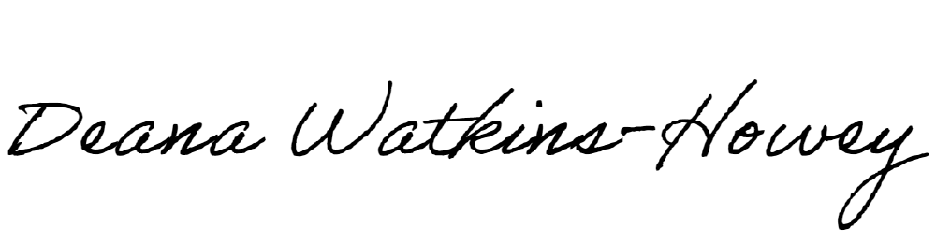
Attest: Deana Watkins-Howey
Development Technician

